Spelling test: Year 5
Given: 10.12.18
Test: 17.12.18
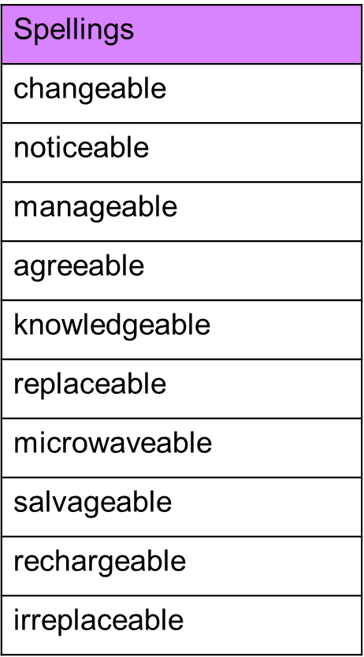

Spelling test: Year 6
Given: 10.12.18
Test: 17.12.18
