Spelling test: Year 5
Given: 4.2.20
Test: 11.2.20
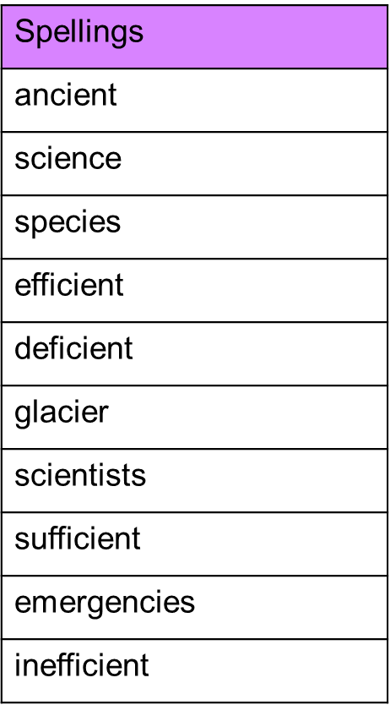

Spelling test: Year 6
Given: 4.2.20
Test: 11.2.20
