Spelling test: Year 5
Given: 17.3.20
Test: 24.3.20
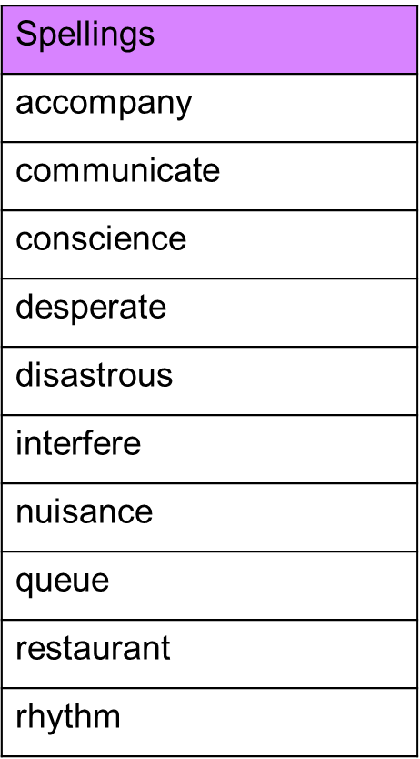

Spelling test: Year 6
Given: 17.3.20
Test: 24.3.20
