Spelling test: Year 5
Given: 21.1.20
Test: 28.1.20
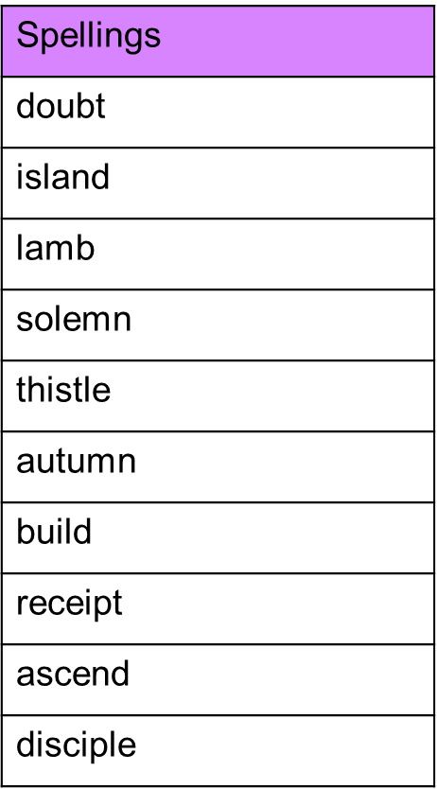

Spelling test: Year 6
Given: 21.1.20
Test: 28.1.20
