Spelling test: Year 5
Given: 3.3.20
Test: 10.3.20
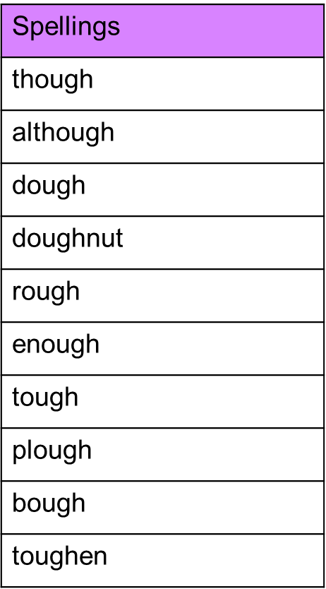

Spelling test: Year 6
Given: 3.3.20
Test: 10.3.20
