Spelling test: Year 5
Given: 10.9.19
Test: 17.09.19
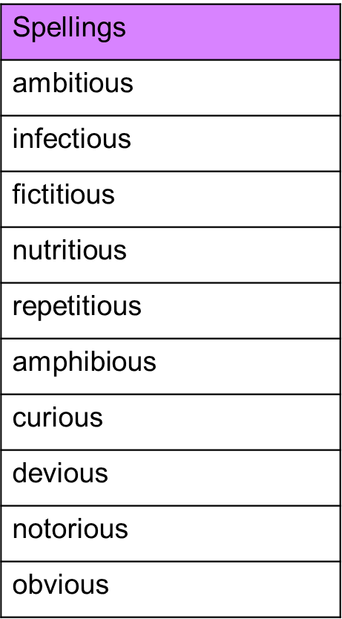

Spelling test: Year 6
Given: 10.9.19
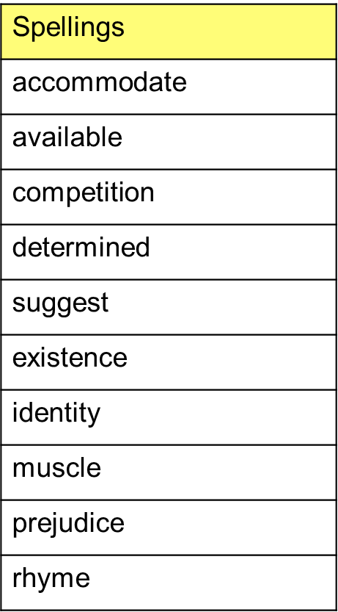
Test: 17.09.19

