Spelling Test: Year 3
Given: 05.11.19
Test: 12.11.19

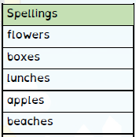
Spelling Test: Year 3
Given: 05.11.19
Test: 12.11.19
Spellings
misbehave
mislead
misspell
mistake
misplace
misread
mislead
misunderstanding
misuse
mislaid

Spelling Test: Year 4
Given: 05.11.19
Test: 12.11.19

Spellings
sadly
completely
wildly
bravely
gently
foolishly
proudly
horribly
nervously
happily

