Spelling Test: Year 3

Given: 17.09.19

Test: 24.09.19

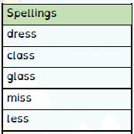

Spelling Test: Year 4

Given: 17.09.19

Test: 24.09.19

Spelling Test: Year 3

Given: 17.09.19

Test: 24.09.19

