Spelling Test: Year 1
Given: 30.09.19
Test: 07.10.19

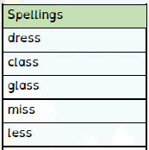

Spelling Test: Year 2

Given: 30.09.19
Test: 07.10.19

