Given: 24.03.20
Test: 31.03.20
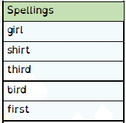

Spelling Test: Year 3
Spelling Test: Year 4
Given: 24.03.20
Test: 31.03.20

Given: 24.03.20
Test: 31.03.20
Spellings
address
arrive
certain
experience
history
mention
occasionally
probably
reign
sentence

Spellings
group
height
particular
potatoes
separate
surprise
through
various
though
woman

