Given: 17.03.20
Test: 24.03.20
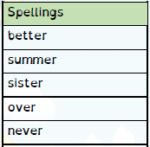

Spelling Test: Year 3
Spelling Test: Year 4
Given: 17.03.20
Test: 24.03.20

Given: 17.03.20
Test: 24.03.20
Spellings
truly
duly
publicly
daily
slyly
shyly
fully
wholly
coyly
happily

Spellings
reluctantly
quickly
generously
unexpectedly
gently
curiously
furiously
seriously
victoriously
courteously

