Spelling Test: Year 3
Given: 03.03.2020
Test: 10.03.2020

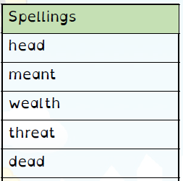

Spelling Test: Year 3
Spelling Test: Year 4
Given: 03.03.2020
Test: 10.03.2020

Given: 03.03.2020
Test: 10.03.2020
Spellings
basically
frantically
dramatically
historically
nationally
emotionally
accidentally
automatically
traditionally
specifically

Spellings
musician
magician
electrician
politician
mathematician
technician
optician
beautician
physician
dietician

