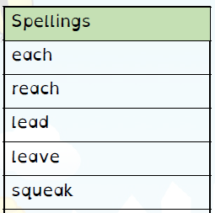
Spelling Test: Year 3
Given: 25.02.19
Test: 03.03.19

Spelling Test: Year 3
Given: 25.02.19
Test: 03.03.19
Spellings
gently
simply
humbly
nobly
simply
terribly
incredibly
responsibly
wrinkly
possibly

Spelling Test: Year 4
Given: 25.02.19
Test: 03.03.19

Spellings
expression
discussion
confession
permission
admission
impression
obsession
procession
omission
concussion

