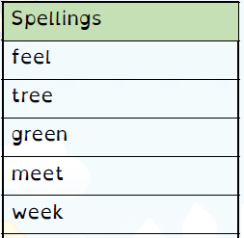
Spelling Test: Year 3
Given: 11.02.2020
Test: 25.02.2020

Spelling Test: Year 3
Given: 11.02.2020
Test: 25.02.2020
Spellings
battle
article
struggle
possible
capable
settle
humble
terrible
example
adjustable

Spelling Test: Year 4
Given: 11.02.2020
Test: 25.02.2020

Spellings
invention
injection
action
hesitation
completion
stagnation
nomination
migration
conservation
selection

