Spelling Test: Year 3
Given: 04.02.2020
Test: 11.02.2020

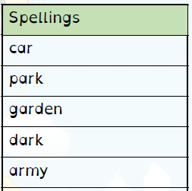
Spelling Test: Year 3
Given: 04.02.2020
Test: 11.02.2020
Spellings
arrival
burial
comical
emotional
national
magical
personal
optional
survival
tropical

Spelling Test: Year 4
Given: 04.02.2020
Test: 11.02.2020

Spellings
naughty
caught
fraught
automatic
astronaut
cause
author
applaud
taught
audience

