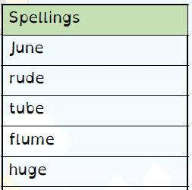
Spelling Test: Year 3
Spelling Test: Year 3
Given: 28.01.2020
Test: 04.01.2020

Given: 28.01.2020
Test: 04.01.2020
Spellings
grate
great
grown
groan
main
mane
meat
meet
missed
mist

Spelling Test: Year 4
Given: 28.01.2020
Test: 04.01.2020

Spellings
breath
business
caught
different
exercise
extreme
medicine
possession
although
thought

