Spelling Test: Year 3
Given: 21.01.2020
Test: 28.01.2020

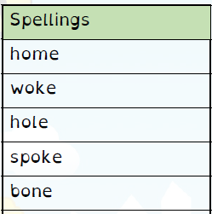
Spelling Test: Year 3
Given: 21.01.2020
Test: 28.01.2020
Spellings
build
describe
imagine
library
natural
ordinary
promise
recent
suppose
weight

Spelling Test: Year 4
Given: 21.01.2020
Test: 28.01.2020

Spellings
serious
obvious
curious
hideous
spontaneous
courteous
furious
various
victorious
gaseous

