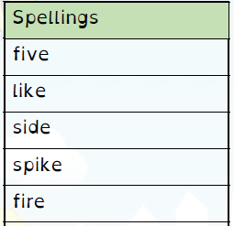
Spelling Test: Year 3
Spelling Test: Year 4
Given: 14.01.2020
Test: 21.01.2020

Spelling Test: Year 3
Given: 14.01.2020
Test: 21.01.2020

Given: 14.01.2020
Test: 21.01.2020
Spellings
calmly
exactly
deadly
bravely
boldly
gladly
deeply
clearly
hourly
quickly

Spellings
merriment
happiness
plentiful
penniless
happily
prettiest
nastiness
beautiful
pitiful
silliness

