Spelling Test: Year 3
Given: 07.01.20
Test: 14.01.20

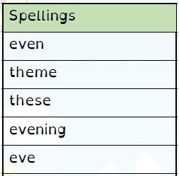
Spelling Test: Year 3
Spelling Test: Year 4
Given: 07.01.20
Test: 14.01.20
Given: 07.01.20
Test: 14.01.20
Spellings
obey
prey
convey
survey
grey
osprey
disobey
they
surveyor
conveyor

Spellings
courageous
outrageous
nervous
famous
adventurous
advantageous
ridiculous
carnivorous
rapturous
torturous

