Spelling Test: Year 3
Given: 12.11.19
Test: 19.11.19

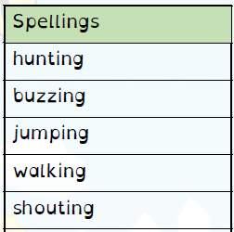
Spelling Test: Year 3
Given: 12.11.19
Test: 19.11.19
Spellings
gardening
gardener
limited
limiting
developing
developed
listening
listened
covered
covering

Spelling Test: Year 4
Given: 12.11.19
Test: 19.11.19

Spellings
usually
finally
beautifully
thoughtfully
wonderfully
carefully
faithfully
peacefully
cruelly
generally

