Spelling Test: Year 3

Given: 03.09.19

Test: 10.09.19

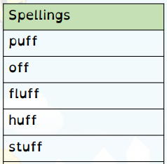

Spelling Test: Year 3

Spelling Test: Year 4

Given: 03.09.19

Test: 10.09.19

Given: 03.09.19

Test: 10.09.19

