ANSON PRIMARY SCHOOL
Class 4 – Week 2
Weekly Learning Tasks
Notice: If you would like your work or photos of what you have been up to this week to appear on our Class 4 ‘Wall of Fame’, please ask a parent to email your work to the class 4 email address (anson.class4@tssmat.staffs.sch.uk). Please also mention whether or not your parents are happy for the work or photo to be displayed on the website.
Why have Weekly Learning Tasks been created?
Weekly learning tasks have been created as a result of the ongoing risk of schools shutting due to the Coronavirus outbreak across the UK. Based on this very real and increasing threat, class teachers have therefore written a set of weekly learning tasks which can be completed by your child whilst schools are closed for a set duration. In creating the weekly learning tasks we fully acknowledge that they cannot replace the quality of learning your child receives at school however, our complete focus has been on creating a set of tasks that all children can access to maximise their learning whilst at home.
What are the aims of the Weekly Learning Tasks?
- To create age specific learning opportunities for primary school children.
- To create a resource for parents that is easy to access and use - the focus is on parents being able to help deliver the content or children accessing it independently.
- Key learning is linked to the National Curriculum.
- To enable children to continue with their learning at home during an enforced shutdown.
- To provide structure and focus to each day when an enforced shutdown occurs.
- To centralise online learning resources and links into an easy to manage format for families.
How do I use the Learning Tasks?
As a parent your first step read the ideas outlined in this document. There is no set time that you should spend on each time but a suggested timetable has been created to help. However it is very much your parental choice how you structure your day and you may wish for your child to spend less or more time on activities.
A mailbox has been set up to receive emails only for any work set outside of the educational programs we use. Please feel free to send work, photographs to your class teacher using the following email address is: anson.class4@tssmat.staffs.sch.uk
We are unable to reply to any emails sent to this address.
If you wish to contact the class teacher please do so as usual by emailing the office email address anson.office@tssmat.staffs.sch.uk. The class teacher will make every effort to respond within 2 working days.
A Suggested Timetable (Just a guide to how a typical day may run).
 | Monday | Tuesday | Wednesday | Thursday | Friday
30 Minutes | PE | PE | PE | PE | PE
1 Hour | Maths | Maths | Maths | Maths | Maths
1 Hour | English | English & Spelling Test | English | English | English
30 Minutes | Reading | Reading | Reading | Reading | Reading
1 Hour | RE | Computing | Topic | Science | Art
20 Minutes | Spelling | French | Spelling | Music | Spelling

What happens if my child finds the learning too difficult? Our first piece of advice to parents is that ALL children find elements of learning challenging at times so try not to worry if your child becomes stuck and you cannot explain it to them. If this happens then make a note of what they found hard and move onto another learning activity - the school will try their best to cover any misconceptions when we return.

Weekly Learning Tasks
Class 4 – Year 5 & 6
Online Programs
(Logins for these programs found in the front of your child’s homework diaries)
Bug Club | https://www.activelearnprimary.co.uk/login?c=0  Differentiated Reading Books, which asks your child questions about the texts.
Education City | https://www.educationcity.com/  Age appropriate Literacy and Numeracy Games  Games the teacher has set will be found on your child’s MyCity Page.  We encourage a score of 80% or more, to ‘Pass’ the game.
Purple Mash | https://www.purplemash.com/login/  Purple Mash hosts an exciting mash-up of curriculum focused activities. Work the teacher has set can be found on your child’s 2do Page.
Doodlemaths/  Doodletables | https://www.doodlemaths.com/ Also available on the APP Store.  Maths and Times tables Programs.  Work the teacher has set can be found on the ‘extras’ part of the Doodlemaths program.
SpellingShed | https://www.spellingshed.com/en-gb /  Also available on the APP Store. Weekly spelling lists are uploaded on this program with activities to try to practise spelling these words.

Year 5/6 School Closure Activities – Week 2 (30th March – 3rd April)
Weekly Maths Tasks | Weekly English Tasks
Education City – Access the games set on MyCity and play one until you get a score of at least 80% (If you complete the set games, and wish to complete more work, please browse education city and practise maths games on other topics that have not been set)  Doodle Maths – Access your ‘Extras’  White Rose Maths – ‘Problem of the Day’ –  White Rose Maths are releasing 3 maths problems each day (Orange banner for KS1 and Blue banner for KS2). Choose a day and try to answer the 3 questions for that day  https://whiterosemaths.com/resources/classroom-resources/problems/page/2/  My Mini Maths – Follow the link to Arithmetic 16 – Target Question 15 (Multiplying fractions). Watch the YouTube video to help you understand how to complete the questions and then answer them on some paper. Can you get full marks?  https://myminimaths.co.uk/arithmetic-16-practice-question-15/ | Education City – Access the games set on MyCity and play one until you get a score of at least 80% (If you complete the set games, and wish to complete more work, please browse education city and practise english games on other topics that have not been set)  Spelling Shed - Practice your spellings on Spelling Shed. Please ask a parent to test you every Tuesday on your spellings (which can be found on the usual page on the school website).  SPAG.com (Year 6 only) – Log onto SPAG.com and complete a test. Check your answers at the end to see where you went wrong  ‘The Tsunami’ – Look at the task sheet attached below. Complete a couple of sections each day, and then write a 500 word story based on what you have created. Please email final story to Class 4 email address.  Extreme Earth Poem – Choose an example of an extreme earth event (volcano, hurricane, drought, tsunami etc.) and create a poem about it. You could create a shape poem, a limerick or a narrative poem. Can you include a rhyming scheme? Send your finished poem to the class 4 email address (document or picture).
Weekly Reading Tasks | Weekly Foundation Subject Tasks
Bug Club – Spend 20 minutes reading a book on bug club and answering the questions in full sentences  Reading for Pleasure – Read a chapter from the book you are reading at home. Note down 5 unfamiliar words and use a dictionary or online dictionary to write the definitions of them  Reading for Pleasure – Read a chapter from the book you are reading at home with someone you live with. When you have finished, create a set of 5 questions about the chapter (what happened, why a character did/said something, what a word means etc.) and challenge your family member to answer them – remember you must know the correct answer too!  Purple Mash – Access your ‘To Do’s’. Re-read ‘Seven Hours to Save the World - Chapter 1’ and then access the To Do called ‘The End of the World?’. Open it and write a diary entry imagining you are the only person left alive. Use the ‘Think About’ section on the left to help you know what to include in your diary entry. Both of these can be found on your ‘To Do’s’. | Topic – Create a ‘Time Capsule’ – We are all living through history right now! In the future, children will learn about this period of time in their history lessons. Make a time capsule that you can look back on the future about what is happening in the world right now!  - Include a letter to your future self (age, best friends, favourite TV show, book etc., what is going on in the world right now, how you are feeling about it, goals and dreams etc.…  - Include newspaper articles from newspapers – what stories are currently hitting the headlines (not just the virus!)  - Draw a picture of your family including pets  - Take photos of what your bedroom looks like, what you are doing today, your family and pets etc.  - Decorate a cardboard box, write the date on it and include all of the things you have collected/created. Put your completed time capsule somewhere safe and where you will forget about it (attic, back of wardrobe, buried in garden etc.)  Music – Write a rap about your life like the one from ‘The Fresh Prince of Bel Air’ that you have been practising in your Music lessons! Film your performance and email it to the Class 4 email address.  R.E – This Sunday is Palm Sunday. Using a strip of brown paper, follow the instructions to create a Palm Cross (instructions attached at bottom of document).

Useful websites:
Storytime with David Walliams – Author David Walliams is reading a story at 11am each day on his website to listen to live https://www.worldofdavidwalliams.com/
Corbett Maths Primary – This website has many useful resources for primary maths, including a ‘5 a day’ challenge, videos and worksheets relating to different areas of the curriculum and maths quizzes for children to complete https://corbettmathsprimary.com/
Newsround – Watch daily with your child and discuss what is going on around the world https://www.bbc.co.uk/newsround
Audible - Audible have made hundreds of children’s book available to stream for free whilst schools are closed https://stories.audible.com/start-listen
Edinburgh Zoo – Edinburgh Zoo have released a link to watch the Rockhopper Penguins (as well as other animals such as tigers, koalas and pandas) live! https://www.edinburghzoo.org.uk/webcams/rockhopper-penguin-cam/#rockhopperpenguincam
Solvemoji – A maths-type game based on using emojis to solve maths puzzles. Guess the number value of emojis in each row and then correctly work out the bottom row sum. A great brain work out! https://www.solvemoji.com/
The School Run – ‘The School Run’ is a very useful website that you can use to help explain terminology that is used in class. For example, if your child is asked to include parenthesis within their work, and they are unsure of what it is or how to include it, you can google ‘the school run parenthesis’ (for example) and usually there is a section that will very clearly explain what it is and how to use it. https://www.theschoolrun.com/

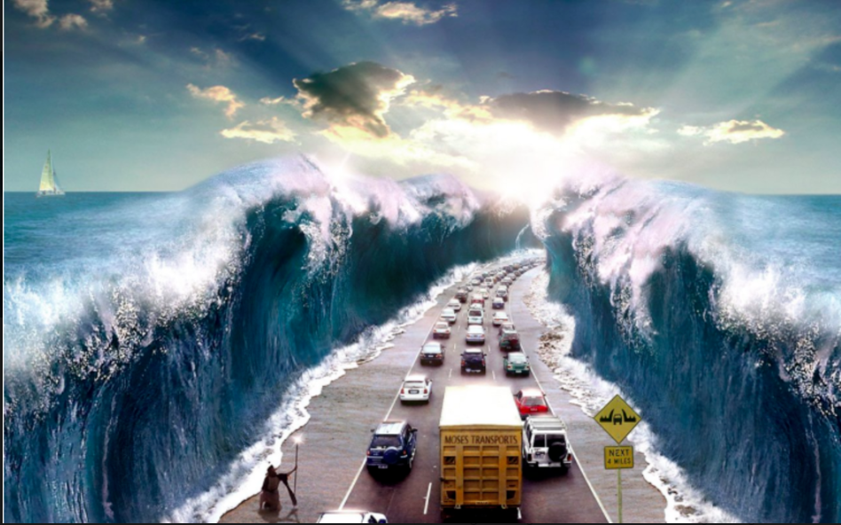
‘The Tsunami’ Task Sheet
Story Starter (to provide ideas if needed)
It was that time again… Our annual surfing trip to Devon. While my parents packed up the suitcases and loaded up the car for the long journey ahead, we chatted excitedly about what an incredible holiday this was going to be! Not too long into the journey, the beautifully clear, blue sky became dark and ominous. All of a sudden, crashing towards the long line of traffic, was a colossal wave – not the kind you’d want to catch on a board either… Desperately, people raced wildly out of their cars, running, screaming and panicking, yet as I looked to my left, I saw a man…

Activity 4: Sick sentences! (Improving their writing)
These sentences are ‘sick’ and need help to get better. Can you help?
The waves fought against the man. He stood still. He waved his staff.
Activity 3: Sentence challenge! (Challenging their writing)
A complex sentence must contain a subordinate clause. This is a clause that doesn’t make sense on its own. E.g. Although the man had miraculously managed to prevent the waves from crashing down onto the people, they were still extremely frightened!
Write a complex sentence of your own and underline your subordinate clause. Try starting your sentence with: As, While, When, If, Even though
Activity 5: Story Time! (Using everything they’ve learnt to write creatively)
Write a 500 word story based on what you have created. Email me your finished stories so I can enjoy reading them! Can you include 5 different uplevelling techniques?
Activity 2: Question Time – Write a response to these questions (Thinking about their writing)
- Who do you think the man is and why is he there?
- How do you think the people who are in the vehicles are feeling at this point and why?
- If you were in one of those cars, what do you think you would do?

Activity 1: Perfect Picture! (Engaging them in writing).
The sea is filled with marine life. Draw what you think the people in the cars might see in the middle of the sea.

