ANSON PRIMARY SCHOOL
Class 3 – Week 2
Weekly Learning Tasks
There are lots of hyperlinks in this document. To activate the links, which are in dark blue text, press ‘ctrl’ and then click the blue link.
Why have Weekly Learning Tasks been created?
Weekly learning tasks have been created as a result of the ongoing risk of schools shutting due to the Coronavirus outbreak across the UK. Based on this very real and increasing threat. Class teachers have therefore written a set of weekly learning tasks which can be completed by your child whilst schools are closed for a set duration. In creating the weekly learning tasks we fully acknowledge that they cannot replace the quality of learning your child receives at school however, our complete focus has been on creating a set of tasks that all children can access to maximise their learning whilst at home.
What are the aims of the Weekly Learning Tasks?
- To create age specific learning opportunities for primary school children.
- To create a resource for parents that is easy to access and use - the focus is on parents being able to help deliver the content or children accessing it independently.
- Key learning is linked to the National Curriculum.
- To enable children to continue with their learning at home during an enforced shutdown.
- To provide structure and focus to each day when an enforced shutdown occurs.
- To centralise online learning resources and links into an easy to manage format for families.
How do I use the Learning Tasks?
As a parent your first step read the ideas outlined in this document. There is no set time that you should spend on each time but a suggested timetable has been created to help. However it is very much your parental choice how you structure your day and you may wish for your child to spend less or more time on activities.
A mailbox has been set up to receive emails only for any work set outside of the educational programs we use. Please feel free to send work, photographs to your class teacher using the following email address is: anson.class3@tssmat.staffs.sch.uk
We are unable to reply to any emails sent to this address.
If you wish to contact the class teacher please do so as usual by emailing the office email address. anson.office@tssmat.staffs.sch.uk. The class teacher will make every effort to respond within 2 working days.
A Suggested Timetable (Just a guide to how a typical day may run).
 | Monday | Tuesday | Wednesday | Thursday | Friday
30 Minutes | PE | PE | PE | PE | PE
1 Hour | Maths | Maths | Maths | ‘Set up Science Activity’  Maths | Maths
1 Hour | English | English & Spelling Test | English | English | English
30 Minutes | Reading | Reading | Reading | Reading | Reading
1 Hour | RE | Computing | Topic | Science | Art
20 Minutes | Spelling | French | Spelling | Music | Spelling

What happens if my child finds the learning too difficult? Our first piece of advice to parents is that ALL children find elements of learning challenging at times so try not to worry if your child becomes stuck and you cannot explain it to them. If this happens then make a note of what they found hard and move onto another learning activity - the school will try their best to cover any misconceptions when we return.
My child is on the SEN register, how can I help? It could also be that learning time at home is used to work on the targets which your child is currently on. These targets were shared with you on their Anson Education Plan at the last termly meeting. In preparation for a potential closure, the school SENCo/Support Team gave some children additional work they can access, if some of the weekly work is too difficult.
Weekly Learning Tasks
Class 3 – Year 3 & 4
Online Programs
(Logins for these programs found in the front of your child’s homework diaries)
Bug Club | https://www.activelearnprimary.co.uk/login?c=0  Differentiated Reading Books, which asks your child questions about the texts.
Education City | https://www.educationcity.com/  Age appropriate Literacy and Numeracy Games  Games the teacher has set will be found on your child’s MyCity Page.  We encourage a score of 80% or more, to ‘Pass’ the game.
Purple Mash | https://www.purplemash.com/login/  Purple Mash hosts an exciting mash-up of curriculum focused activities. Work the teacher has set can be found on your child’s 2do Page.
Doodlemaths/  Doodletables | https://www.doodlemaths.com/ Also available on the APP Store.  Maths and Times tables Programs.  Work the teacher has set can be found on the ‘extras’ part of the Doodlemaths program.
SpellingShed | https://www.spellingshed.com/en-gb /  Also available on the APP Store Weekly spelling lists are uploaded on this program with activities to try to practise spelling these words.
Weekly Maths Tasks
- This week we will practise co-ordinates. We have looked at co-ordinates in class. The children may remember the rhyme ‘Along the corridor, and up the stairs.’ This helps them with remembering to read the horizontal axis first, then then the vertical axis.
Education City – My City – Games to practise co-ordinates. ONLY some of the games are Ipad/Iphone friendly. More games will show on a computer.
(If you want to vary learning, I have set a variety of interactive games and worksheets. If you don’t have access to printing facilities, playing just the interactive games is fine).
- If you have got the boardgame ‘Battleships’. This is a great time to play this game together so you can practise co-ordinates.

- Practise finding the perimeter of shapes. This is the measurement around the edge of the shape. I have included some ‘Learn Screens’ on Education City, which help to teach this concept to pupils. We have done some work on this in class.
Education City – My City – Games to practise finding the perimeter. (A piece of paper for working out may be needed). ONLY some of the games are Ipad/Iphone friendly. More games will show on a computer.
(If you want to vary learning, I have set a variety of interactive games and worksheets. If you don’t have access to printing facilities, playing just the interactive games is fine).
- Find the perimeter of tables/rugs/rooms in your house.
Too easy? Convert these measurements from cm to m / m to cm / cm to mm / mm to cm.

- Please continue working on practising your child’s times tables and the inverse division problems.
E.g. 3 x 5 = 15 / 5 x 3 = 15 / 15 ÷ 3 = 5 / 15 ÷ 5 = 3
Practising of times tables can be done in a variety of ways:

- Play on Hit the Button - focus on times tables
- Practise Multiplication Olympics – Sheets can be printed directly from the About Class 3 Page on our website.
- Purple Mash – 2do – Multiplication Check
- Education City – My City – A Variety of Multiplication Games have been put on
- Education City – Play Live
- Doodletables – On the Ipad
- Got a nerf gun? Focus on a particular times table – Stick answers on post it notes on the wall. Test your child by asking them questions and they have to ‘fire’ at the answer. Haven’t got a nerf gun? Don’t worry just ask them to tap the answer, like a speed reaction game.
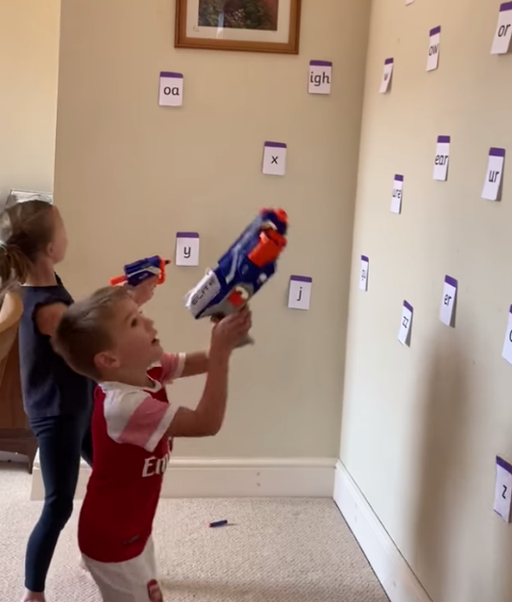

Weekly English Tasks

An enlarged version of the picture can be found on page 14 . Use this picture to help with the following activities.

Activity 1: Perfect Picture! (Engaging them in writing).
Imagine you can see through Poppy’s eyes. Can you draw what she can see?

Activity 2: Question Time – Write a response to these question (Making them think about their writing)
What do you think it is that Poppy and Jasper have seen?
Where do you think Poppy got the aircraft from?
What will happen next?
Where do you think they had planned on going?
Will they reach their destination?
Do you think it’s hard to be a pilot?
What skills do you think a pilot needs to possess?
Do you think being a pilot is an interesting job? Why?
Activity 3: Sentence challenge! (Challenging their writing)
FOCUS: Powerful Adjectives
Education City – MYCITY – Has a range of games set on it this week, to help with adjectives. Get your child to play some of the games before completing the task.
Can you make a list of feelings that Poppy might be experiencing in the plane? E.g. Excited, shocked, nervous…
Remember we call these words adjectives as they describe the noun.
Can you start a sentence using one of these feelings?
E.g. Shocked, Poppy gasped as she noticed that it was now flying next to them.
Terrified, Jasper let out a loud howl as they entered the thick cloud.
(Notice I’ve use a comma after each adjective. Don’t forget yours!)
Ask your child to write 8 sentences, about the picture, which start with an amazing adjective.

Activity 4: Sick sentences! (Improving their writing)
These sentences are ‘sick’ and need help to get better. Can you help?
The plane went through the sky.
It was cloudy.
The wind blew.
Ask your child to up level the sentences above and write some more up-levelled and exciting sentences of their own using the adjectives they came up with in activity 3.
Challenge: Can you start your up levelled sentences with an adjective?
Activity 5: Story Time! (Using everything they’ve learnt to write creatively)
Miss Humphries Story Starter:
Flying is supposed to be fun, right? Poppy often dreamed about what her first flight would be like. She’d imagined it was like being a bird; free and weightlessly drifting through the clouds. The first part of the journey had been exactly as she’d hoped it would be. Jasper agreed, signalling his enjoyment by barking enthusiastically from the co-pilot’s seat. Things were about to take a drastic turn for the worse…
Can your child write/continue the story about the flight?
Email me their finished stories so I can enjoy reading them! Can I spot those amazing adjectives?

Weekly Reading Tasks |  | Weekly Spelling Tasks
- Purple Mash – Access your ‘To Dos’. Read chapter 1 of the book I have set you, then try the Multiple choice quiz, which asks you questions about the chapter you have read.  (Both chapter 1 and the multiple choice quiz can be found on your ‘ToDo’s).  - Listen to one of David Walliams audio books which he releases daily on the website. What happened? What did they think of the story? What would they change if they could write the story?  - Get your child to read a book on Bug Club and complete the activities. They will practise their comprehension skills. Encourage them to refer back to the text.  - You could share a story together. This could be a chapter book where you read and discuss a chapter a day.  - Listen to your child read and let them discuss what they have read. Encourage them to read with expression and intonation. |  | - Test your child’s weekly spellings every Tuesday. (Their latest spelling list can be found on the class page)  - Practise your spellings on Spelling Shed  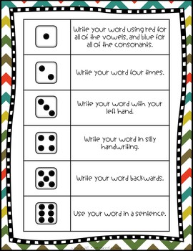  - Grab a dice and play my spelling dice game below. It’s a great way of practising your spellings.
RE |  | Computing
Produce a poster showing what different symbols surrounding Easter mean  (e.g. spring flowers, eggs, lambs,).  Use the Picture Cards below of different Easter symbols as a starting point for ideas. Make sure children understand that Easter is about the promise of new life. |  | 2DO – Purple Mash – Unformatted Newspaper  In computing we are going to be looking at the unit  ‘Writing for different audiences’  Children should open the newspaper front page set as a 2Do and try to edit the text to make it look like a proper newspaper front cover. They should select the ‘A’ tool and format the text appropriately to make it look like a proper newspaper.  There are some photos in the gallery that children can add by clicking on the green cross in the picture box. The lower picture box can be used to upload a picture that children have found by doing an internet search. They should then save and hand in their work.
Topic – Ancient Egypt |  | Design and Technology - Shaduf
LO - To learn about Egyptian tombs, pyramids and burial  sites.  Ask children to research the Egyptian beliefs on life and death. How are these beliefs different from beliefs about life and death today?  Then ask your child to research the process of mummification, and how and why bodies were preserved.  Children should write a set of instructions for mummifying a body. Use the jumbled up sentences below to help.  Please ask your child to think carefully about how to lay these instructions out so that they are clear and easy to read.  Should they include equipment list? Bullet points? Title? Subheadings?  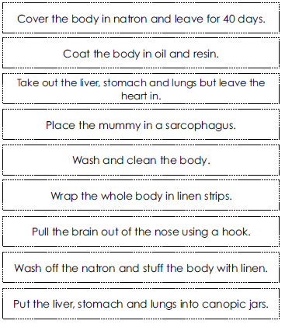 |  | Last week, for home learning your child planned an Egyptian Shaduf using items found around the house.  Children should follow their designs to create their model.  Encourage children to work with care and attention to detail and to amend their design as and when necessary to improve their finished product.  Please keep these designs, so children can evaluate them next week.  Please send a photo of the completed design to anson.class3@tssmat.staffs.sch.uk  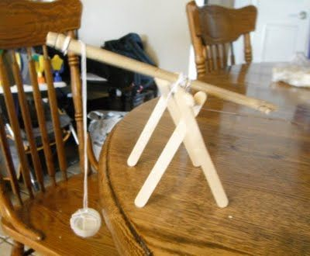  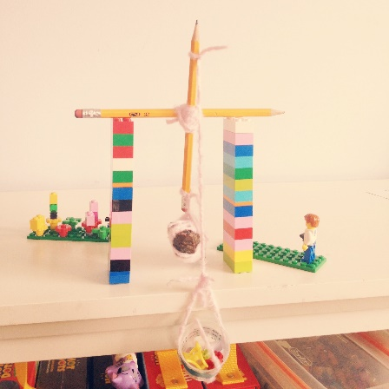  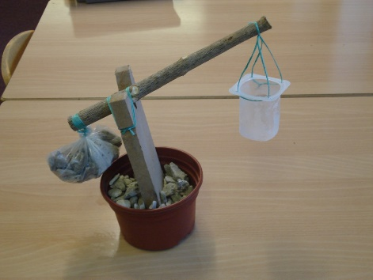
Science – Light & Dark |  | French
LO - To investigate how the size of shadows change  throughout the day.  Show children the picture on the slide of a stick casting a shadow from the Sun. Can you explain what is happening in the picture?  Now show children the stick at two different times of the day. Do they think the shadow will be the same?  Will it be in the same place? Why or why not? Discuss ideas.  (Enlarged versions of pictures can be found on page 12).  - Today they will explore what happens to shadows throughout the day.  - Set up a shadow stick in the garden and record the length of the shadow at five different times (ideally two in the morning, one at midday and two in the afternoon) during the day.  - Write a prediction for what they think will happen to the length of the shadow at the different times during the day.  - Your child should record the results. When finished, they could create a bar graph of the results too.  - Ask your child to explain what they learnt. Why do they think this happened?  - Please help your child by explaining why the shadows changed as they did.  ‘The sun rises in the east and sets in the west’  Struggling for time? - Education City – My City – Learn Screens and Games have been set up to learn how the size of shadows change throughout the day.  ONLY ONE activity is Ipad/Iphone friendly. More games will show on a computer. |  | Now you have created a rainbow of French colours, play the Education City games I have set on My City  Unfortunately none of the education games set are tablet friendly so please access the games on a laptop or computer.  Alternatively colour the picture in the correct colours, using the key.  (enlarged version of the picture can be found on page 13)  Where there isn’t a number, choose your own colour.  No printer? Ask you child to create their own simple picture and key.
Music |  | PE
Below are the lyrics to a song about the Ancient Egyptians. Come up with your own tempo, beat and rhythm, and sing the song. This may take a few attempts to get it right. Feel free to make annotations on the lyric sheet.  Everyone’s version of the song will be different. Can you use musical instruments to accompany it?  Feeling confident? Get a family member to video you, and watch yourself back. What did you do well? How could you improve?  The Nile was the mother of Egypt  Her waters made fertile its fields,  Though eastward and westward lay deserts,  The valley gave excellent yields.  The Ancient Egyptians were farmers,  Who learnt to use wool from their sheep,  The first to domesticate cattle,  To plough and to sow and to reap.  They worshipped their gods in their temples,  Whose splendour the years cannot mar,  Their priests were intelligent people,  Who studied the planets and stars.  Their kings they would bury most nobly,  In tombs that were pyramids tall,  The coffin they placed in a chamber,  With paintings on every wall.  Inventing a writing with pictures,  They left an account of their laws,  The names of their gods and their rulers,  A list of their victories and wars.  So never forget the Egyptians,  The earliest civilised men,  And let us give thanks to the scholars,  Who brought all their art to our ken. |  | - Create your own circuit at home. How many members of your family can complete it?  Get some exciting ideas for your circuit from this website:  https://www.actionforhealthykids.org/activity/backyard-fitness-circuit-course/  - Get out into the garden, pull up some weeds or mow the lawn? Does the garden need a tidy up? Maybe you could plant some seeds.  - Try one of Joe Wicks Live PE Lessons each morning at 9 am.  - Go Noodle with the family or have a family workout.  - Fancy a dance? There are lots of dance videos they could try. Dance.  - Maybe try some Yoga.
Additional Activities
- Practise the Year 3/4 for Common Exception words

- Watch Newsround and discuss what is happening in the wider world.

- Use some of the educational programs outlined at the top of this documents for further learning .

- Time to Talk: Were their family members all born in this local area? If not, how is their place of birth different to their own local area? If they were, how different is the local area since they were born? Talk about their memories of how it has changed.

Science – Picture 1:

Science – Picture 2:

